SIMATS ENGINEERING (SAVEETHA SCHOOL OF ENGINEERING)
Department of Computer Science and Engineering
ASSESSMENT TOOL 3 – DEBUGGING & OPTIMISATION TASK
Course Code: | CSA0615 |  | Course Title: | Design and Analysis of Algorithms
CO Assessed: | CO2 – Manipulation (BL1, BL2, BL3) |  | Assessment: | Assessment Tool 3 – Debugging & Optimisation Task
Weightage: | 10% of CIA |  | Total Marks: | 100
CO2 Statement: | Apply Brute Force technique to solve sorting, searching, Closest-Pair and Convex-Hull problems  (BL1, BL2, BL3)
Student Name: | Lella Thannveer Reddy |  | Reg. No.: | 192524293
Section / Batch: | Slot - A |  | Date: | 07/08/2026
Instructions to Students
- Answer ALL debugging and optimisation tasks. Total Marks: 100.
- Carefully analyze the given program/code segment before identifying errors.
- Clearly identify logical, syntactical, and performance-related issues in the code.
- Apply systematic debugging techniques to correct the errors effectively.
- Optimize the given solution by improving efficiency, reducing unnecessary computations, or enhancing time complexity wherever possible.
- Provide proper justification for all corrections and optimization decisions.
- Write clean, structured, and well-documented code with appropriate comments.
- Maintain clarity, logical reasoning, and technical accuracy throughout the solution.
Question Type |  | Focus Area |  |  | Questions Marks
Debugging & Optimisation Task |  | Identify errors, debug programs, and optimize algorithm efficiency using appropriate techniques |  |  | Q1 - Q2 | 100 (2 × 50)
 |  | GRAND TOTAL: |  |  | 100 Marks

1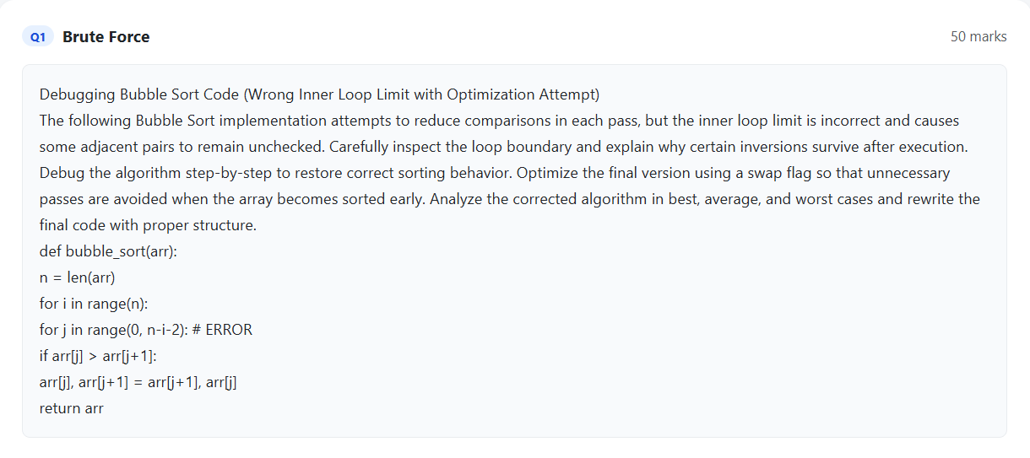

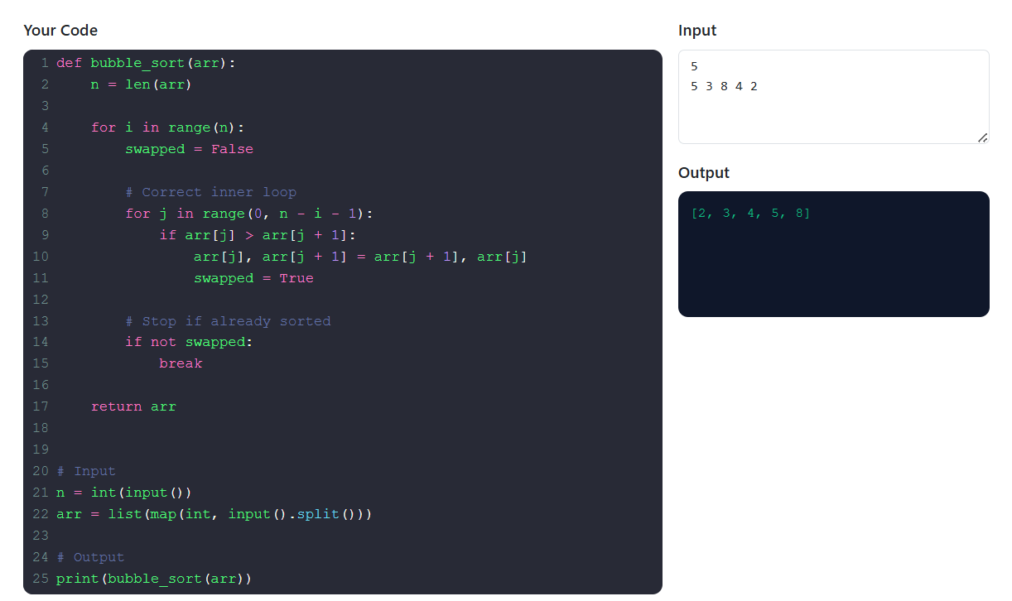

2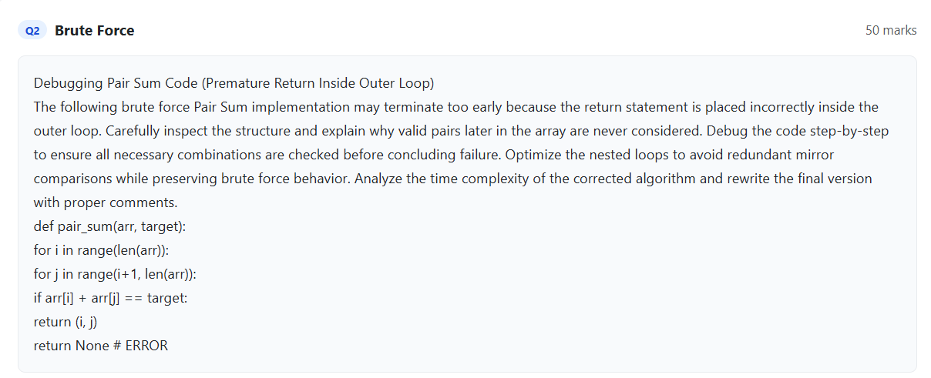

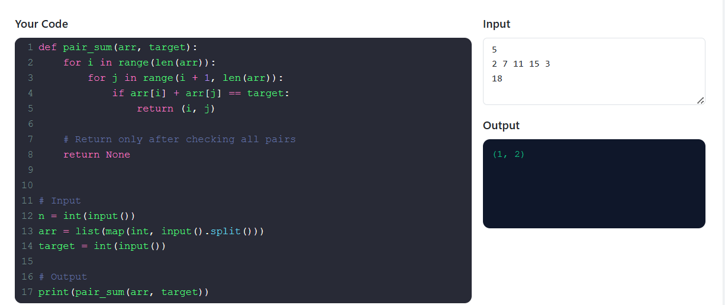

Code of Conduct
I _Lella Thannveer Reddy/192524293_ (Name / Reg No) certify that this submission is my original work and that I have adhered to the guidelines specified for this assessment. I understand that any violation of academic integrity rules will result in disciplinary action.
Signature of the Student: 
Question No. | Problem  Identification (20%) | Debugging (25%) | Optimization (20%) | Analysis (20%) | Code Quality (15%) | Total Marks (Each – 50)
Q1
Q2
 |  |  |  | Overall Total (100)
Faculty In-charge | Course Coordinator | Head of Department
Signature: _______________ | Signature: _______________ | Signature: _______________
Date: ___________________ | Date: ___________________ | Date: ___________________
RUBRICS FOR CALCULATION

Criteria Wt. |  | Level 4 – Exemplary | Level 3 – Proficient | Level 2 –  Developing | Level 1 –  Beginning
Problem  Identification | 20% | Accurately identifies all errors and root causes with clear understanding | Identifies most  errors with minor gaps | Identifies some errors but misses key issues | Unable to identify errors correctly
Debugging | 25% | Applies systematic debugging techniques effectively to resolve issues | Uses appropriate debugging methods with minor errors | Limited debugging approach; requires guidance | Unable to debug or resolve issues
Optimization | 20% | Optimizes code by significantly improving time complexity using efficient algorithms | Improves time complexity with minor gaps in efficiency | Limited improvement in time complexity | No improvement;  inefficient  approach retained
Analysis | 20% | Demonstrates strong logical reasoning and clear justification of solutions | Shows reasonable  analysis with some  justification | Limited analysis; weak reasoning | No analytical reasoning demonstrated
Code Quality | 15% | Produces clean, wellstructured code with proper comments and documentation | Code is mostly clear with minor documentation gaps | Code lacks structure and proper documentation | Poorly written code with no documentation
Marks Evaluation:

